Guidance for appropriate usage of the Signpost 2.0 Tool in Stockport

Purpose
The purpose of this document is to propose the guidance to be provided to locality footprint social workers on the appropriate usage of the Family Context tool. This proposal has been developed to align the usage of the tool with existing social work practice as much as possible.

Background
The guidance proposed in this document has been shaped and approved by service leads and Information Governance in Stockport.

Consent
‘Consent’ may carry different meanings to social workers and information governance professionals.
To information governance professionals Consent is one of several possible lawful bases for processing personal data under the UK General Data Protection Regulation (UK GDPR). Consent is not the lawful basis for the usage of Family Context when conducting a child and family assessment. Rather, the lawful basis for usage of Family Context is Legal Obligation (S47) and Public Task (S17)
However, it is vital that prior to completing a child and family assessment under section 17 of the Children’s Act that agreement is gained from the family to undertake the assessment. This is an important consideration for social workers when they think about appropriate usage of The Family Context tool. Please note the use of the term ‘agreement’ in this circumstance instead of consent. As previously mentioned, consent is not the lawful basis for the provision on Section 17 Assessments or the use of the Family Context tool.
Summary of proposed guidance for using the Family Context tool in Stockport – key questions answered

When a social worker has been allocated a child and family assessment, do they need to have an agreement conversation with the family before they use Family Context?
- For Section 47 cases they do not need to do this. Legally the Family Context tool can be used in these cases without further consideration. If a case steps down to Section 17 then the guidance below applies.
- For Section 17 cases ​social workers or triage staff need to ensure that agreement to undergo an assessment has been sought from the family. This agreement should be transparent, and the family should be advised that this will include compiling a record on the family including service involvement flags and details and potentially making contact with and sharing information with other services. Agreement to undergo the assessment will be sought by First Response social workers if a MASSH enquiry has been completed. This is recorded on the MASSH enquiry form that is copied forward from EHM (Early Help module) to LCS (Children’s System). The allocated social worker must do this before searching the tool.

In cases where they should have an agreement conversation, who should that be with?
- Current practice maintained: the conversation is typically with one of the child’s main caregivers who holds parental responsibility.

How should social workers have that agreement conversation?
- Current practice maintained: when social workers talk to families to gain their agreement to conduct an assessment, they explain they will share information and talk to other agencies.
- Social workers should ensure that families understand fully what they are agreeing to. This is the basis by which we will work with them for cases under S17.
- Parents/Carers should be informed that they:
  - are agreeing to completion of a child and family assessment to identify areas of support.
  - understand that as part of that assessment we will be obtaining and sharing relevant information about them and their family
  - can exercise any of their rights under the UK GDPR at any time
  - can visit the Council’s website to view the relevant privacy notice if they would like further information https://www.stockport.gov.uk/privacy-notices/stockport-family-children-in-need-families-allocated-a-social-worker

Which individuals can a social worker view information on in Family Context?
- Any individual linked to the family who the social worker believes is relevant to the assessment they are conducting.

How can social workers use the information presented in Family Context?
- To assist them as they complete the assessment, including activities such as:
- Call services and speak to practitioners
- Speak to other individuals relevant to the case
- Share information with other services
- Record any information from the tool or from the resulting conversations in Liquid Logic
The screens a social worker sees in Family Context are shown next, alongside the guidance on whether the social worker should have had the agreement conversation before viewing it.

Screen 1: Social workers search for an individual who is, or is relevant to, the subject of a referral

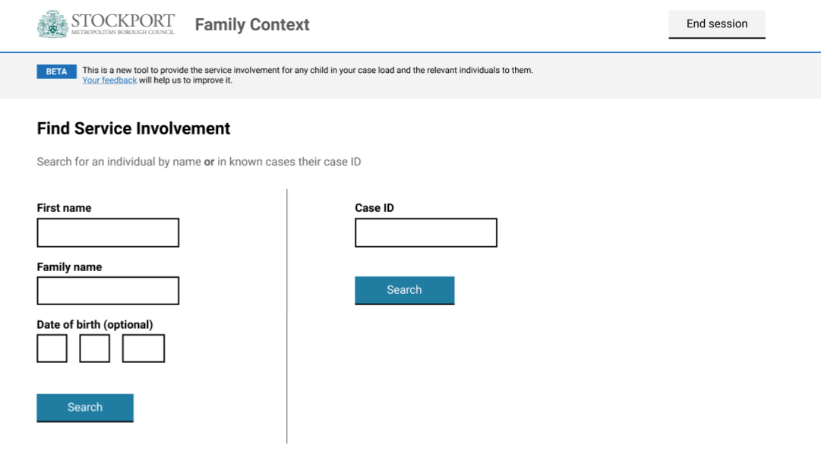
Consent conversation required to view this screen? Yes

Screen 2: Social workers select the appropriate individual from a list of matches
Consent conversation required to view this screen? Yes for section 17
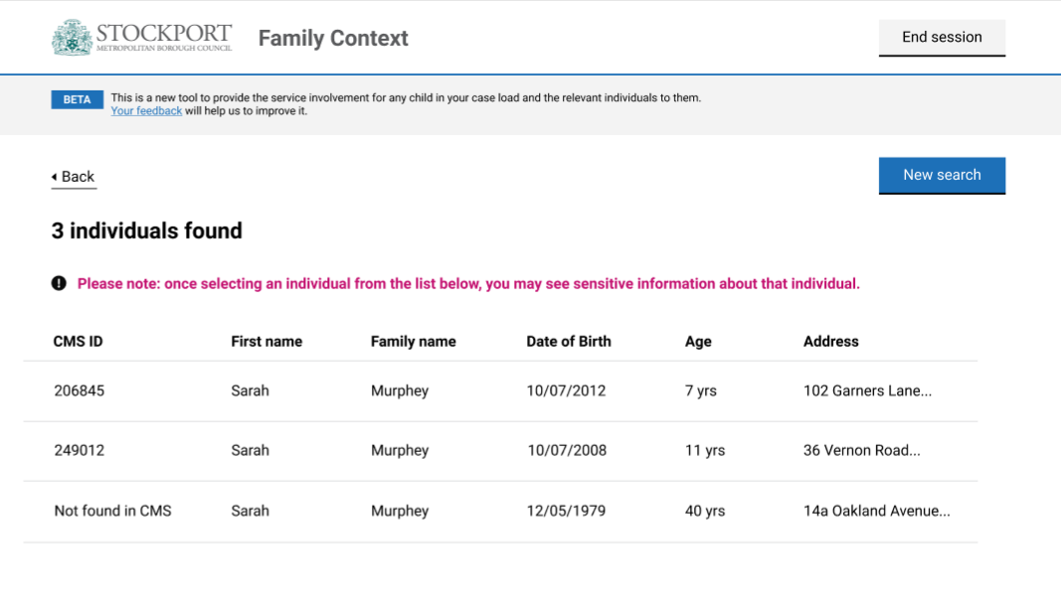

Screen 3: Social workers view basic details about that individual, and service involvement flags.
Consent conversation required to view this screen? Yes for section 17
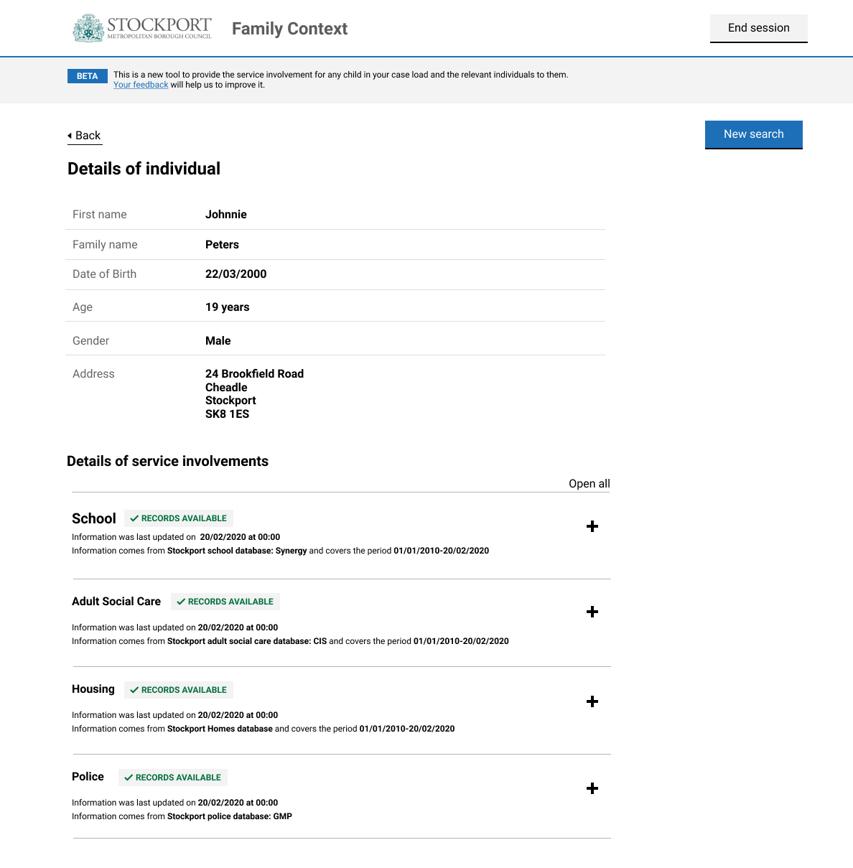

On both screen 3 and screen 4, the section for a given service will only appear on for an individual if their age means it is relevant. The proposed conditions under which the section for a given service appears on these screens are laid out in the table below:
Service | Service section is shown for individuals aged
School | 4 - 20 years old
Adult Social Care | 16 years old and over
Housing | 16 years old and over (to be confirmed with Stockport Homes)
Police | 18 years old and over

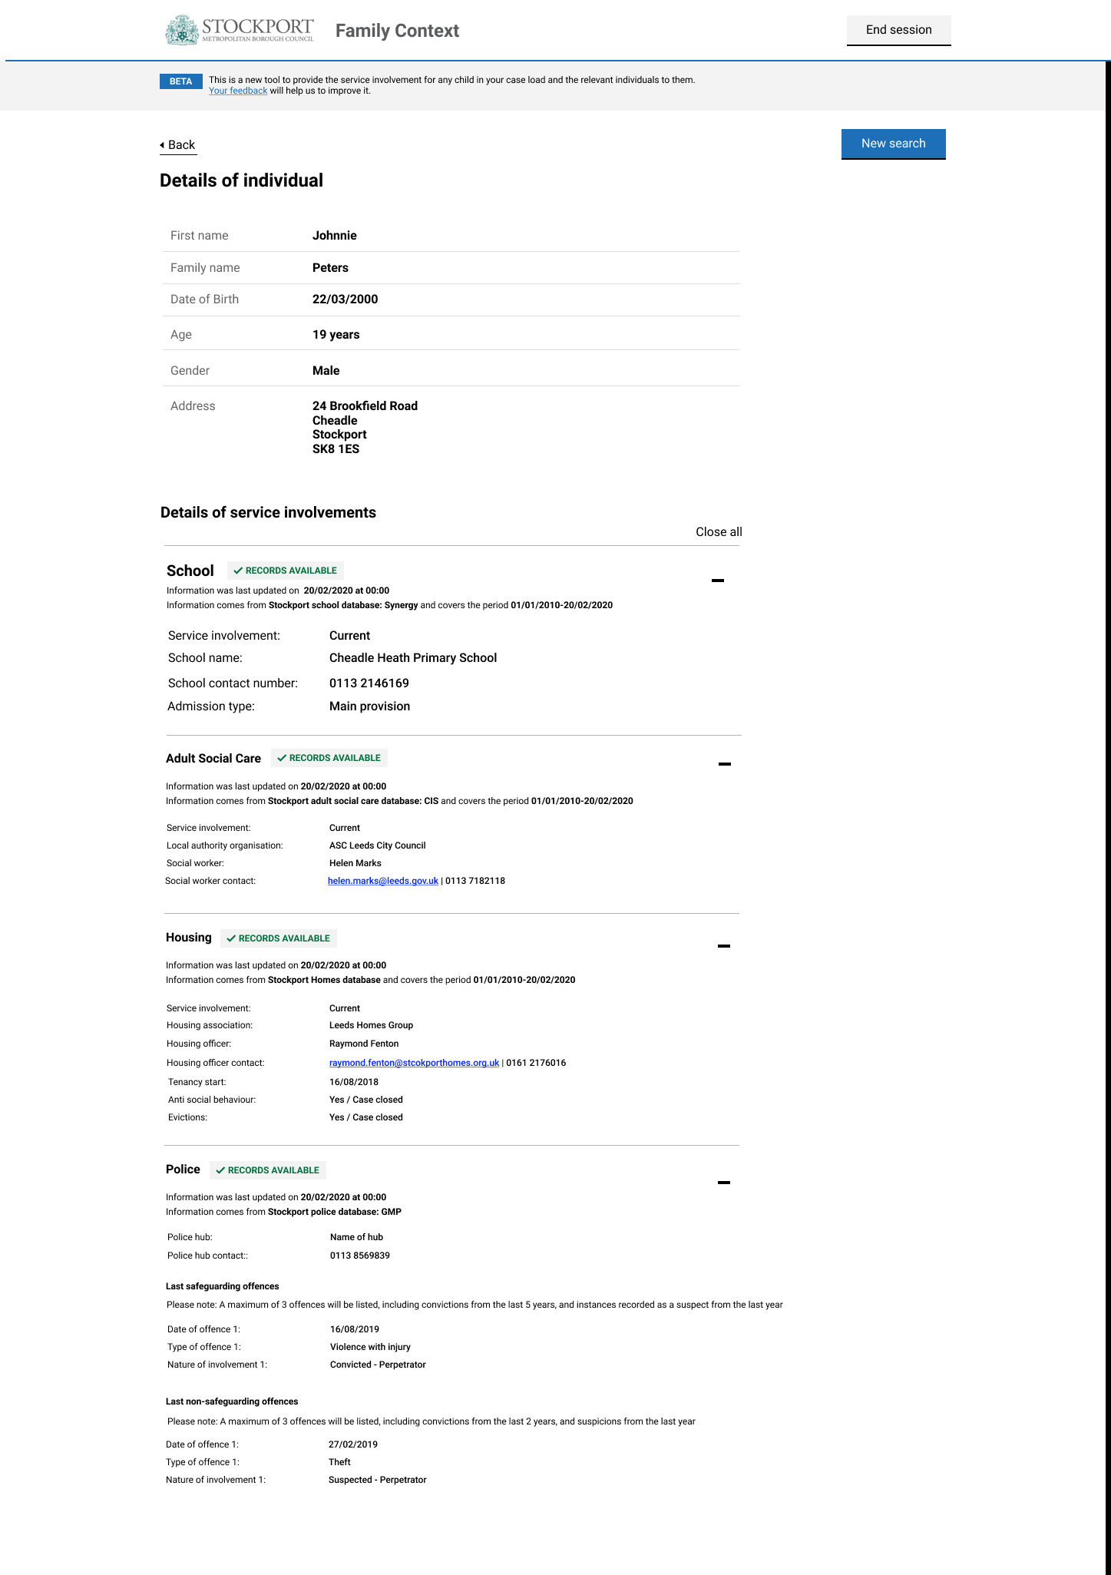
Screen 4: Social workers view basic details about that individual, and service involvement details. As shown in previous table, the section for a given service will only appear on for an individual if their age means it is relevant. Consent conversation required to view this screen? Yes for section 17

Proposal for audit log
The intention is for the tool to have an audit log that enables team leaders and service leads to audit Family Context tool and investigate any misuse of tool by social workers.
We propose that team leaders and service leads can audit the tool at four different levels:
- Audit searches performed by social worker. Team leaders and service leads should be able to track searches performed by social workers including the date and time of the search, search details and name and ID of the social worker.
- Audit search results presented to social worker. Team leaders and service leads should be able to track the search results presented to social workers including the date and time of in which search results were presented, individual details of people presented to SWs and name and ID of the social worker.
- Audit access to details of individual and service involvement flags. Screen 3 contains personal details of the individual, as well as service involvement flags. Team leaders and service leads should therefore be able to understand when screen 3 has been seen by social workers, including the date and time in which the information was presented as well as the name and ID of the social worker.
- Audit access to service involvement details. Team leaders and service leads should be able to understand which service involvement details (screen 4) have been seen by social workers including the date and time in which the information was presented as well as the name and ID of the social worker.

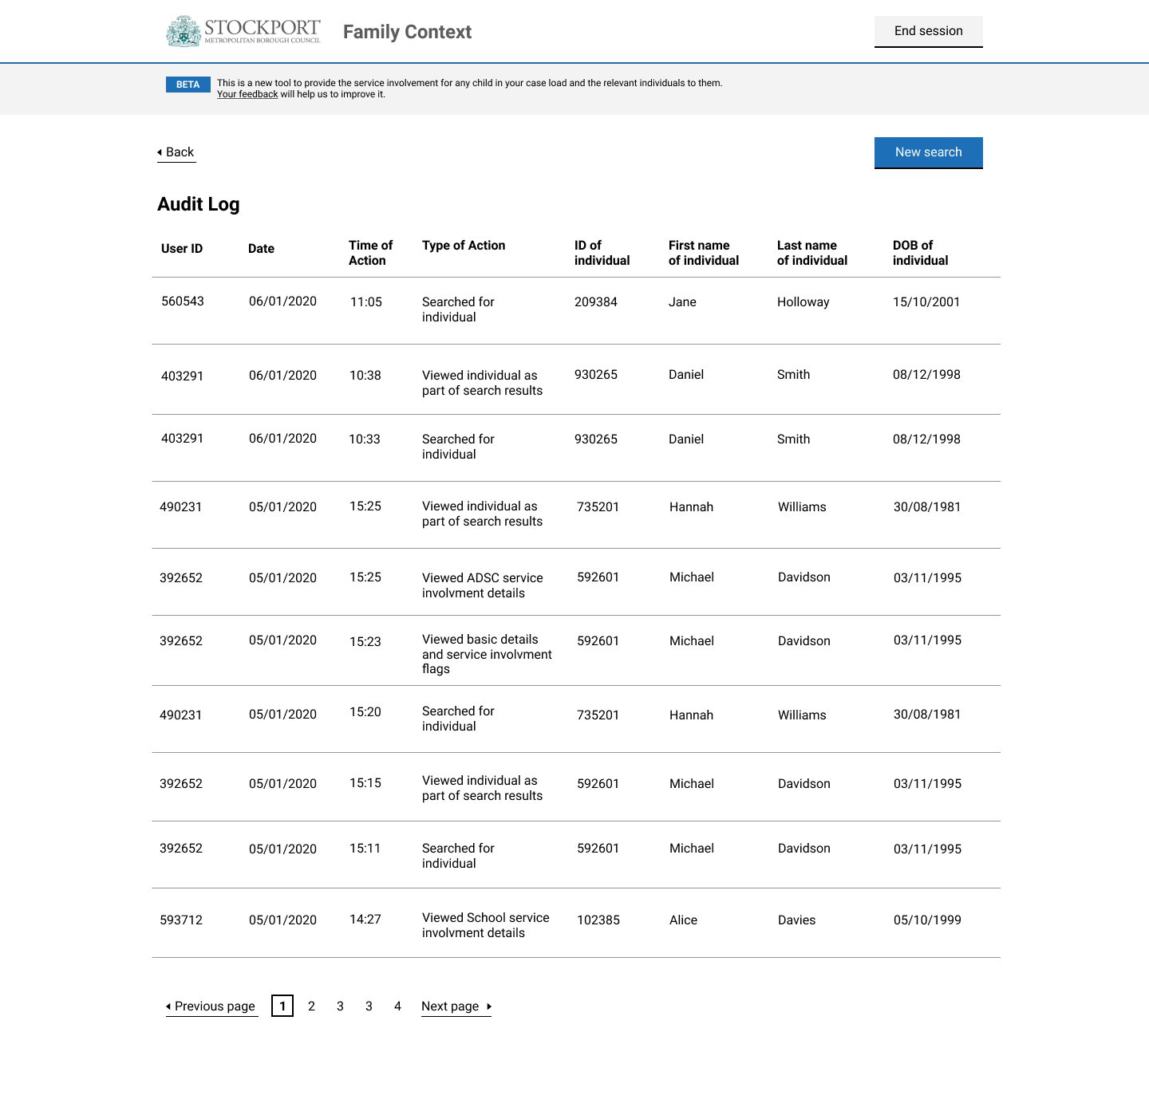
Audit Log

Types of actions captured in Stockport audit log
1) SW searched for individual
2) SW viewed individual as part of search results
3) SW viewed basic details about that individual, and service involvement flags
4) SW viewed School service involvement details
5) SW viewed Adult Social Care service involvement details
6) SW viewed Housing service involvement details
7) SW viewed Police service involvement details

